ANNEX III

TEMPLATE OF THE DOCUMENT BY WHICH THE DOMAIN NAME APPLICANT EXPRESSES AWARENESS AND ACCEPTANCE OF THE ".es" DOMAIN NAME ASSIGNMENT REGULATIONS, CONSENTS TO TRANSFERRING HIS OR HER PERSONAL DATA TO RED.ES FOR THAT PURPOSE, AND AUTHORISES THE REGISTRAR TO ACT ON HIS OR HER BEHALF

…………………….., as applicant for the domain name …………………….. .es (hereinafter, "the Applicant") hereby states that:

- The REGISTRAR …………………….. [commercial name of the registrar] (hereinafter, "the Registrar") is authorised to act on his or her behalf before Red.es (hereinafter, either "the Register" or "the Assignment Authority"), and to take all actions necessary to assign and renew the domain name …………………….. .es (hereinafter, "the Domain Name"), including receiving the corresponding notifications.

- The REGISTRAR is authorised to act in any way necessary to make the payments corresponding to the assignment and renewal of the Domain Names, on his or her behalf, and he or she hereby requests that this be done in subsequent years.

- He or she has been duly informed by the REGISTRAR and is aware of the applicable regulations and procedures, terms and conditions, fees and payment methods and technical requirements established to register ".es" domain names with the mediation of an accredited REGISTRAR, and accepts them in their entirety. Specifically, the Applicant states that he or she understands the regulations, procedures, terms and conditions for registering an ".es" Domain Name, the content of which is available at:
http://www.dominios.es/dominios/en/todo-lo-que-necesitas-saber/normativa

- He or she understands that failure to comply with these regulations shall result, in the cases in which it is thus expressly established, in the loss of the domain name and possible reassignment of the same from that very moment for registration in favour of another eligible applicant.

- Excepting errors or omissions in good faith, the data provided on this application are true.

- He or she agrees to keep the information provided on this application updated at all times, notifying any changes to the REGISTRAR, which will notify Red.es whenever there are modifications to any of the data to be submitted to the Register. Failure to fulfil this obligation may result in the cancellation of the Domain Name (for example, because it is impossible to contact the individuals listed as domain name managers, since changes to their contact data or new managers were not reported as established).

- He or she accepts that Red.es, in carrying out the different actions related to the assignment and renewal of the Domain Name, will act in accordance with the data notified by the Applicant as indicated in the section above.

- He or she understands and accepts that any false data provided on this application could lead to the rejection of the same or, if the Domain Name had already been assigned, the Name could be cancelled and, in this case, the Domain Name would be available for registration by any other eligible applicant.

- He or she understands and accepts that, once the Register notifies the REGISTRAR that the Domain Name may be assigned or renewed because the requirements established for that purpose have been met, the REGISTRAR shall be required to make payment, on behalf of the Applicant and within the established periods of time, of the amounts for the assignment or, when appropriate, renewal, and that failure to make payment or insufficient payment after the established periods of time shall be grounds for making the Domain Name available, from that moment, for registration in favour of an eligible applicant, with Red.es assuming no liability whatsoever for the consequences of the Registrar's failure to fulfil its obligations to the Applicant.

- He or she understands and accepts that the REGISTRAR plays an intermediary role in the assignment of ".es" domain names, and is solely and exclusively responsible for compliance with the requirements stipulated in the mediation contract for the assignment of domain names. The Applicant is considered to have been informed of this situation and expressly waives the right to any action or claim against Red.es due to the Registrar's failure to fulfil its obligations.

- He or she understands and accepts that, in the event of serious technical negligence, a domain name may be cancelled temporarily or permanently.

- To the best of his or her knowledge, the use of the Domain Name does not infringe upon the rights of third parties.

- He or she understands and accepts that the assignment and registration of the Domain Name gives exclusive rights to its use, in the terms set forth in the applicable legislation, for the purposes of addressing in the internet domain name system, and that any dispute over the right to use a particular domain name must be resolved between the parties using the channels legally established for this purpose.

- He or she understands and accepts that the administrative contact person designated on the application and who signs this document with sufficient power of attorney to do so, is responsible for any problem related to the right to use the domain name, and that this is understood and accepted by that person.

- All entities and individuals related to this application understand and expressly accept, in accordance with Organic Law 15/1999, dated 13 December: the Personal Data Protection Act, that the personal data provided to the REGISTRAR and the data included in this document are included in the internal and public databases maintained by Red.es and that they will be kept as such in the terms required for the management of the ".es" Domain Name Register, under the terms established in the <<Rules and Procedures for the ".es" DNS Domain Name Register>>.

- He or she declares that all entities and persons listed in this application are aware, in accordance with the provisions of Regulation (EU) 2016/679, of the European Parliament and of the Council, of 27 April 2016, on the protection of natural persons with regard to the processing of personal data and freedom of information and circulation of these data, which repeals Directive 95/46/EC (General Data Protection Regulation), of the following basic information on the protection of their personal data:

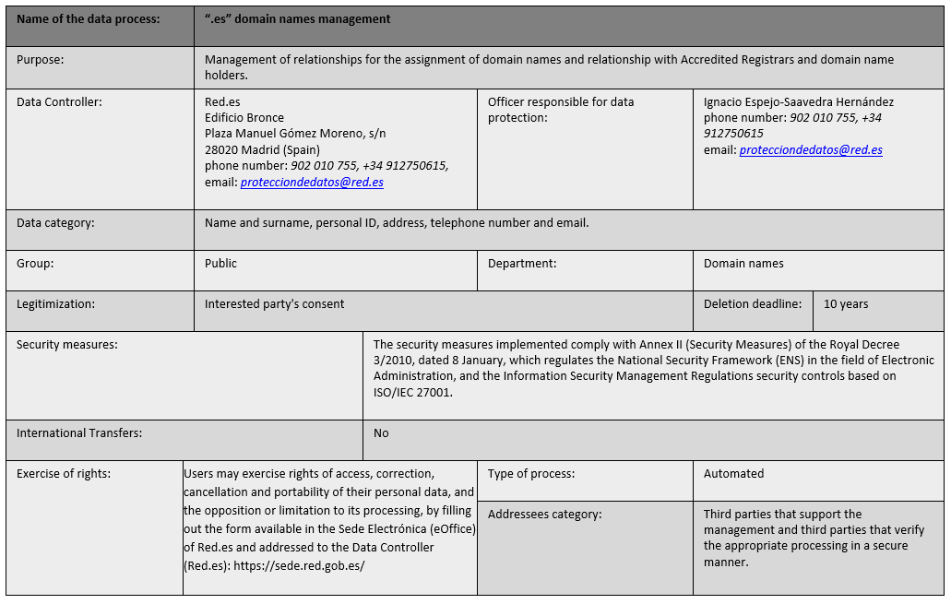
- He or she declares that all the entities and persons listed in this application expressly consent to their personal data being provided to the REGISTRAR and to those included in this document being processed by Red.es for the following purposes:
- Registration of the necessary data for the assignment, operation and renewal of the domain name
- Registration in internal databases for management of the ".es" Register (.es Domains)
- With other Public Authorities with which Red.es enters into agreements.
All this in accordance with the terms established in the Rules and Procedures for the Registration of a Domain Name under ".es".
- He or she declares that all entities and persons listed in this application are aware that, in accordance with the Additional Provision Eighteen of Law 14/2000, of 29 December, on fiscal, administrative and social order Measures, the Public Corporate Entity Red.es will publicise the procedures for the assignment and registration of ".es" domain names that are adopted, and that this will imply that the forename and surnames, in the case of natural persons, the trade name, in the case of legal persons, and the e-mail in all cases, will be communicated through WHOIS, TCP protocol for queries/responses regarding said data, as well as through those tools that Red.es enables for queries relating to that data.
- He or she is aware of and accepts that the rights of access, rectification, deletion and portability of data and the limitation or objection to the processing thereof may be exercised with respect to …………………….. [Trade name of the REGISTRAR] at its registered address located at …………………….. or directly vis-à-vis Red.es as data controller. The rights of cancellation or objection may only be exercised once the application for the domain name has been withdrawn, since it is necessary for Red.es to process personal data for the purpose of assigning or renewing the domain name.
RED.ES, whose website address is www.red.es, shall comply with the provisions of Regulation (EU) 679/2016 on the processing of personal data of the aforementioned persons and entities. Without using them for any purpose other than that leading to the assignment and renewal of the domain name and its advertising in the terms described above. The personal data processed by Red.es will not be transferred nor will they be accessible by any other third party, unless such transfer is required by law, by a regulatory provision or by a court ruling, or if this disclosure is necessary to ensure protection and defence of their rights. Red.es, in registering the ".es" domain name, has the authority to outsource services related to correct registration, such as developments, operation, attending to Registrars and End Users, Security etc. In these circumstances, the subcontractors of Red.es will be subject to the same clauses of confidentiality and personal data processing.

In …………………….., on ….. of …………………….. of 20….
_________________
Signed: (Administrative Contact) Mr./Mrs. …………………….. with ID no. ……………………..
ANNEX III bis

SPECIFICATIONS FOR THE VALID ACCEPTANCE OF THE CONDITIONS SET FORTH IN ANNEX III OF THE ACCREDITED REGISTRAR CONTRACT BY AN “.ES” DOMAIN NAME HOLDER

To enable the Assignment Authority to accredit and, where appropriate, verify acceptance of the conditions set forth in ANNEX III of the Registrar Contract (hereinafter, “the Contact”), the means used by the Registrar to obtain this authorisation, whether electronic or written, must guarantee that the authorisation has been obtained.

The form of obtaining the acceptance of the conditions outlined in ANNEX III of the Contract will only be deemed valid if it complies with the following specifications, distinguishing between whether the authorisation is obtained by electronic means or in writing:

ONE.- Accredited Registrars must store and guard their clients' acceptance of the abovementioned conditions in ANNEX III of the Accredited Registrar Contract, both in electronic form and in writing for the set legal period.

Acceptance of the conditions contained in ANNEX III of the Accredited Registrar Contract of one or several holders of “.es” domain names must be made available to the Assignment Authority upon the latter's request.

TWO.- Acceptance of the conditions in ANNEX III may be provided to the holder of the domain name in any of the following ways:

a) In writing, without altering their content in any way:
1. By providing the new domain name holder with the abovementioned document for signing, separately from the contract used with its clients for the provision of goods and services, prior to registration of the domain name to which the contract with the Accredited Registrar pertains.
2. As an ANNEX to the contract for the provision of services.
b) By electronic means: The Registrar will keep evidence of the explicit acceptance of ANNEX III by the domain name applicant. For the purposes of practical implementation, among others, the following will be considered as evidence of such approval:
- The log file generated by the telematic application used by the Registrar to register “.es” domain names, when the domain name applicant ACCEPTS the conditions in ANNEX III. Holders of “.es” domain names must be provided with these conditions in unabridged form.
In the system log developed by the Accredited Registrar, the following information must appear as a minimum: The domain name applicant's identifier (that the system has verified), the future holder of the domain name and the domain name being requested.
- The date and time of the log shall be stored in the system at the time when the domain name applicant ACCEPTS the application and has previously viewed and accepted the conditions set forth in ANNEX III.
- Timestamping of the acceptance of the conditions contained in ANNEX III that the applicant has explicitly ACCEPTED.
- Electronic signature of the acceptance of the conditions of ANNEX III by the applicant and/or Holder of the domain name.
- Any other acceptance or evidence that may be used by the Registrar shall be communicated to Red.es for validation as correct practical implementation that guarantees, unequivocally and reliably, the rights of the holders of ".es" domain names.
Notwithstanding the foregoing, Registrars must inform Red.es of any change they may make to the policy for registration of ".es" domain names, both technically and operationally.

ANNEX IV

TEMPLATES FOR THE CLAUSES THAT THE REGISTRARS MUST INCLUDE IN THE CONTRACTS THEY SIGN WITH THEIR CUSTOMERS

1. Data protection

The REGISTRAR must include a clause in the contract entered into with the applicant to obtain the applicant's consent for their personal data to be processed by the REGISTER. Said clause shall be along the following lines:

"The personal data provided by the applicant will be notified to the Public Business Entity Red.es, located at www.red.es. Said notification is necessary to execute this contract. The applicant undertakes, to this effect, to keep the information provided up-to-date by way of the procedure established for said purpose.
In processing the applicant's personal details, the Entity shall act in accordance with the provisions of the General Data Protection Regulation (Regulation (EU) 679/2016), not using them for purposes other than those set forth herein and in the regulations governing the assignment of “.es” domain names. Applicants are informed that assignment of the domain name necessarily requires that their personal data be published in the Registry Database of ".es" domain names, accessible to the public via Internet. In signing this document, the Applicant gives consent for data transfer and processing, including the publication of personal data in the Registry Database of ".es" domain names.
The rights of access, rectification, deletion and portability of data and the limitation or objection to the processing thereof may be exercised vis-à-vis …………………….. [Trade name of the REGISTRAR] at its registered address located at …………………….. or directly vis-à-vis Red.es as data controller.

2. Non-liability of the Register in aspects related to the contractual relations established between the Registrars and the ".es" domain name applicants or beneficiaries

To guarantee the REGISTER's impunity, the REGISTRAR shall include the following clause in all contracts entered into with the domain name applicants or beneficiaries:

“…………………….. [Commercial name of the REGISTRAR] exercises a mediation function in the assignment of ".es" domain names and is solely and exclusively responsible for fulfilling the obligations stipulated in this contract. All ".es" domain name applicants or beneficiaries who sign this contract shall be deemed to have been informed of this situation and they expressly waive any right to any action or claim against Red.es deriving from …………………….. [commercial name of the REGISTRAR]'s failure to fulfil its duties.”

Registrant terms and conditions
http://www.dominios.es/dominios/en/todo-lo-que-necesitas-saber/sobre-registros-de-dominios/terms-and-conditions

